**JAVA PROGRAMMING QUESTIONS**

1. Write a program to check whether a given string is a palindrome or not using for loop and if-else statement.

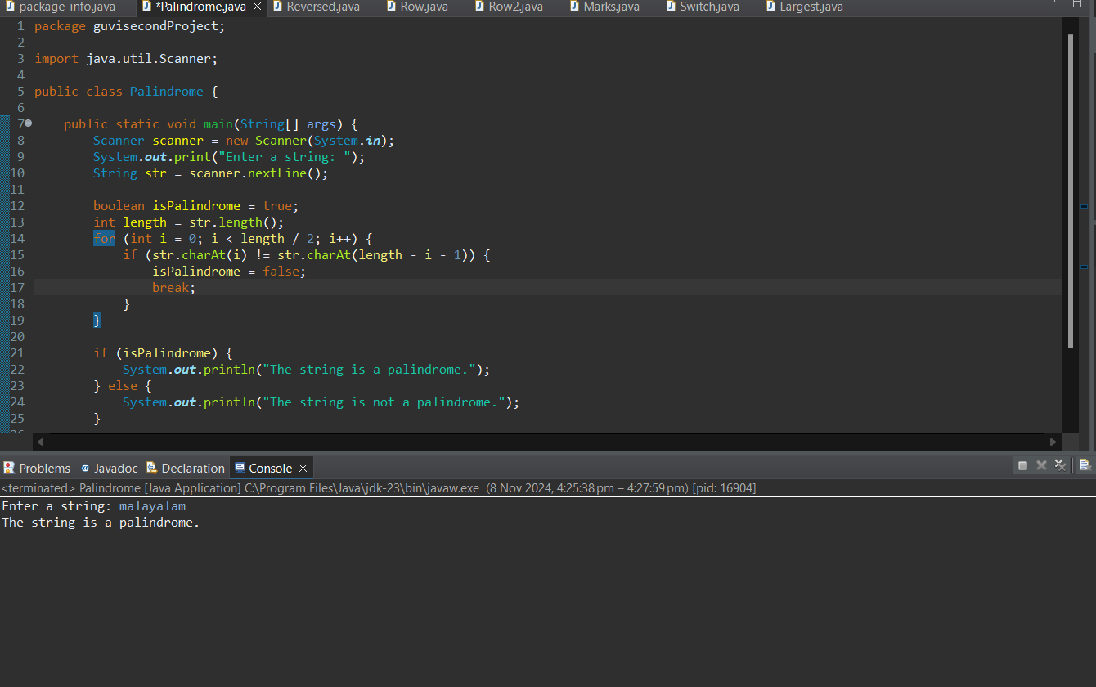

1. Write a program that reads in a string from the user and uses a loop to reverse the order of the characters in the string. Then, output the reversed string.

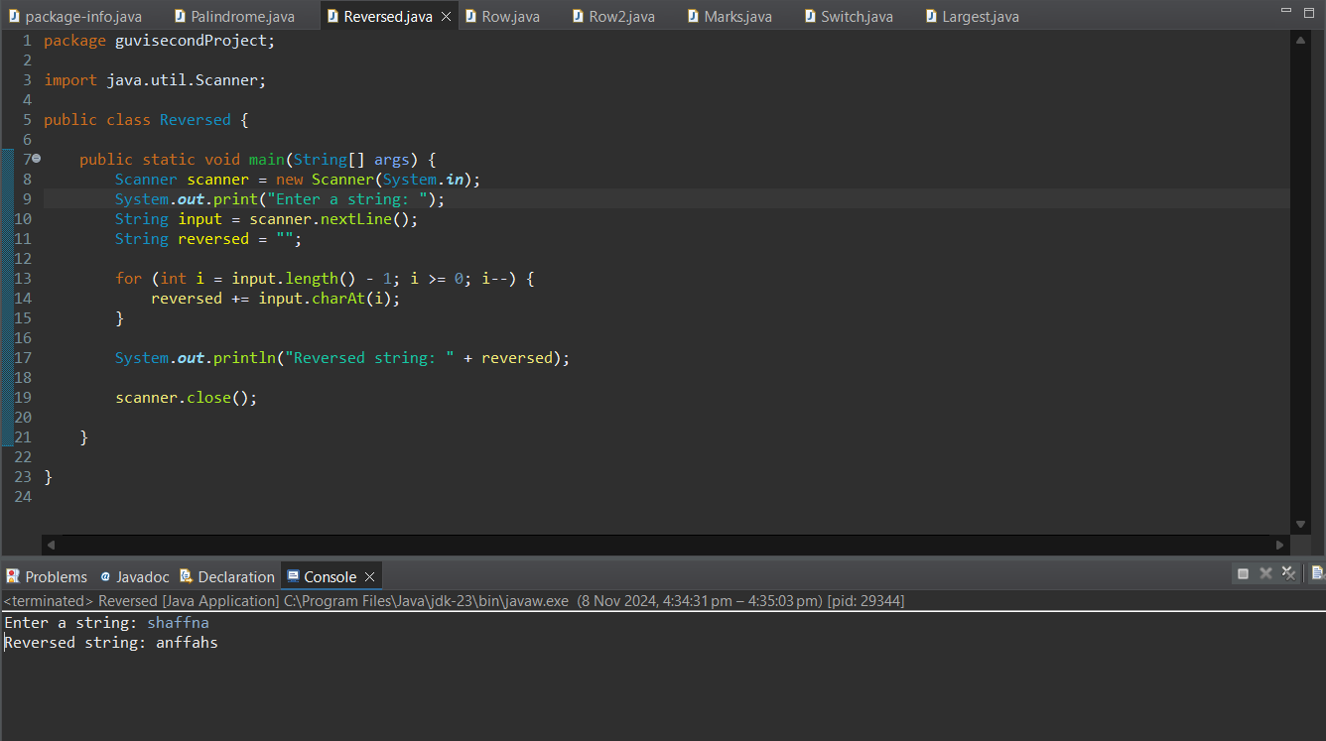

1. Write a program to print the given below pattern.

Sample Input:

4

Sample Output:

1

2 3

4 5 6

7 8 9 10

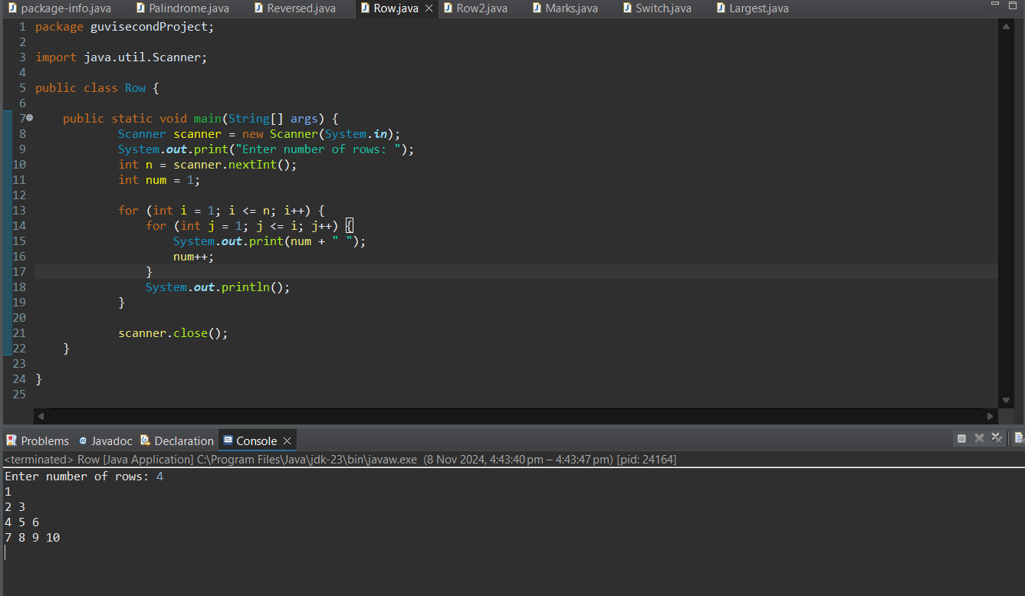

1. Write a program to print the given below pattern.

Sample input:

5

Sample output:

* *

* *

*

* *

* *

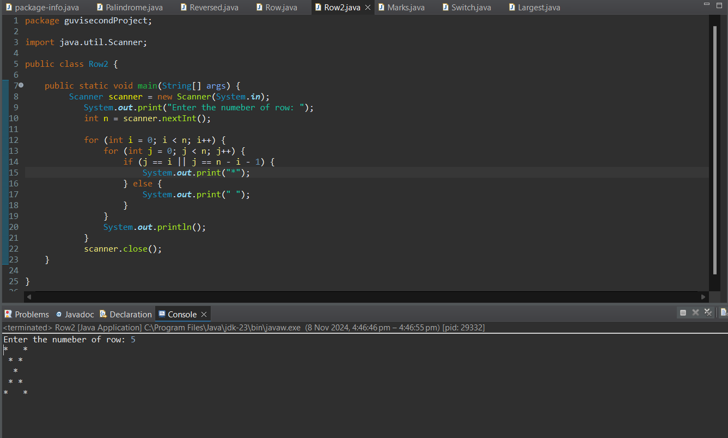

1. Anna University Grading System The newly appointed Vice-Chancellor of Anna University wanted to create an automated grading system for the students to check their grade. When a student enters a mark, the grading system displays the corresponding grade. Write a program to solve the given problem.

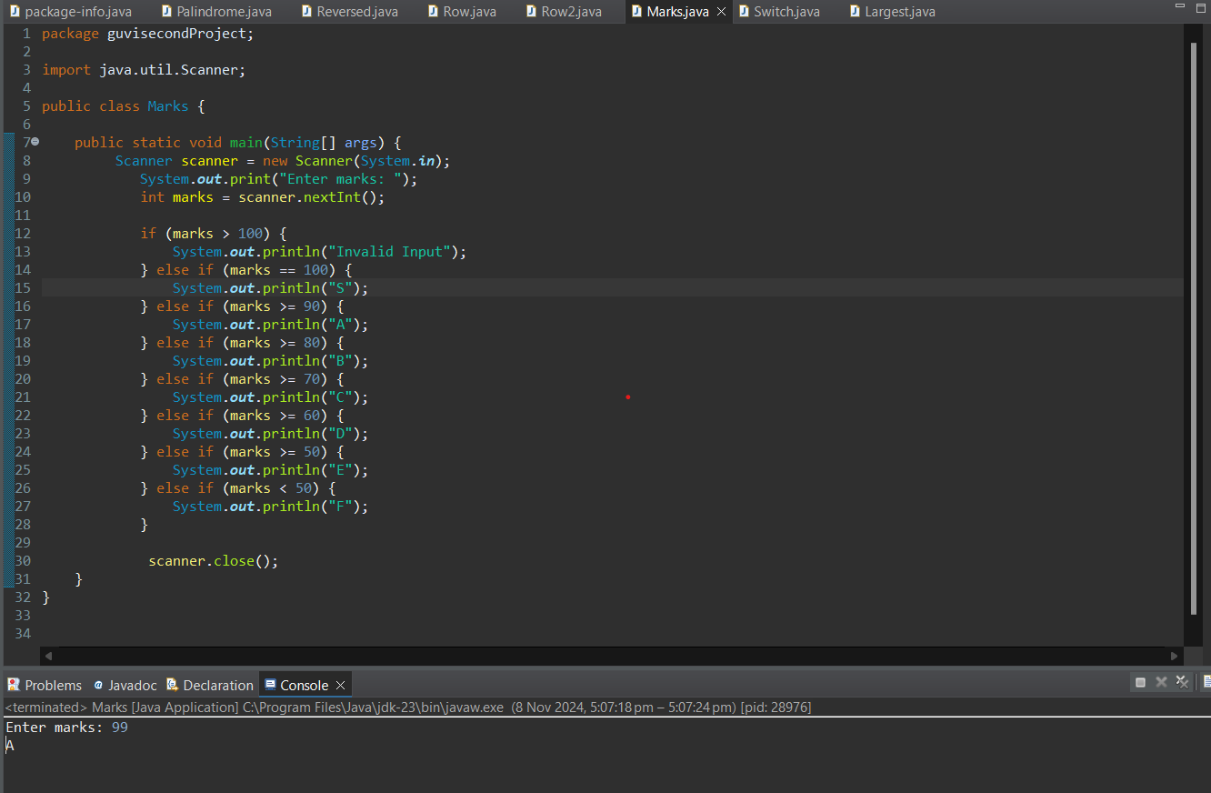

1. Write a program to calculate the hotel tariff.

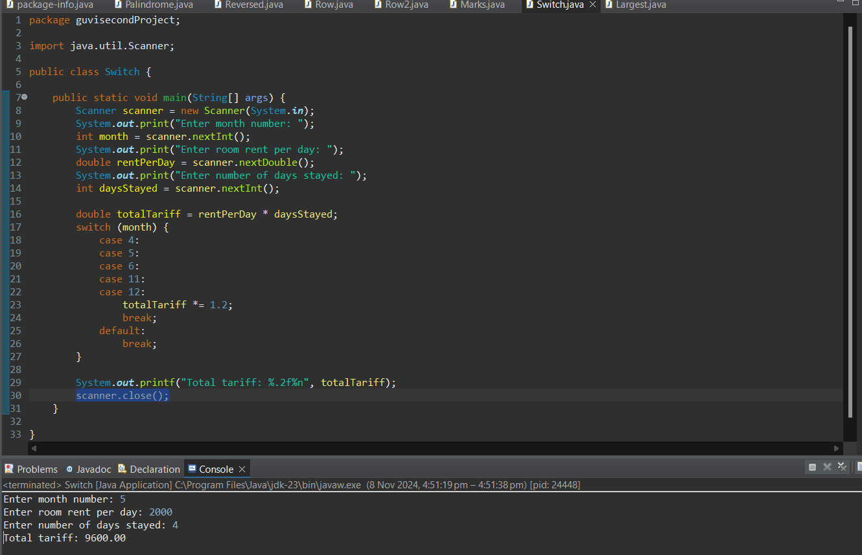

1. Write a program to calculate the largest number among three numbers.

